Vehicle Management System

**1. Vehicle_types:**

INSERT INTO vehicle_types(

wheels, type_name)

VALUES (2, 'Scooter');

INSERT INTO vehicle_types(

wheels, type_name)

VALUES (2, 'Bike');

INSERT INTO vehicle_types(

wheels, type_name)

VALUES (3, 'Auto');

INSERT INTO vehicle_types(

wheels, type_name)

VALUES (4, 'Car');

INSERT INTO vehicle_types(

wheels, type_name)

VALUES (4, 'Truck');

INSERT INTO vehicle_types(

wheels, type_name)

VALUES (4, 'Bus');

**2. Manufacturers:**

INSERT INTO manufacturers(

manu_name, manu_address, manu_contact, manu_email)

VALUES ('Honda','Gujarat, India',07922816263, 'contact@honda.com');

INSERT INTO manufacturers(

manu_name, manu_address, manu_contact, manu_email)

VALUES ('Hero','Karnataka, India',07922815001, 'contact@heromoto.com');

INSERT INTO manufacturers(

manu_name, manu_address, manu_contact, manu_email)

VALUES ('Maruti Suzuki','Sikkim, India',07922818412, 'contact@maruti.com');

INSERT INTO manufacturers(

manu_name, manu_address, manu_contact, manu_email)

VALUES ('Tata','Surat, India',07925064723, 'contact@tata.com');

INSERT INTO manufacturers(

manu_name, manu_address, manu_contact, manu_email)

VALUES ('Hyundai','United States',101012356, 'contact@hyundai.com');

INSERT INTO manufacturers(

manu_name, manu_address, manu_contact, manu_email)

VALUES ('Mahindra','Punjab, India',918489781203, 'contact@mahindra.com');

INSERT INTO manufacturers(

manu_name, manu_address, manu_contact, manu_email)

VALUES ('Renualt','Pune, India',918489785465, 'contact@renault.com');

INSERT INTO manufacturers(

manu_name, manu_address, manu_contact, manu_email)

VALUES ('Volvo','California',01450567821, 'contact@volvo.com');

INSERT INTO manufacturers(

manu_name, manu_address, manu_contact, manu_email)

VALUES ('Volkswegan','India',919875785465, 'contact@volks.com');

INSERT INTO manufacturers(

manu_name, manu_address, manu_contact, manu_email)

VALUES ('Ford','Karnataka, India',919425385465, 'contact@fiat.com');

**3. Vehicle_models:**

INSERT INTO vehicle_models(

model_name, unit_type, cubic_cm, manu_id, type_id)

VALUES ('Activa','LTR', '110', 1,1);

INSERT INTO vehicle_models(

model_name, unit_type, cubic_cm, manu_id, type_id)

VALUES ('Honda City','LTR', '1500', 1,4);

INSERT INTO vehicle_models(

model_name, unit_type, cubic_cm, manu_id, type_id)

VALUES ('Indigo','LTR', '1200', 4,4);

INSERT INTO vehicle_models(

model_name, unit_type, cubic_cm, manu_id, type_id)

VALUES ('i10','LTR', '1000', 5,4);

INSERT INTO vehicle_models(

model_name, unit_type, cubic_cm, manu_id, type_id)

VALUES ('Zen','LTR', '800', 3,4);

INSERT INTO vehicle_models(

model_name, unit_type, cubic_cm, manu_id, type_id)

VALUES ('CB Shine','LTR', '150', 1,2);

INSERT INTO vehicle_models(

model_name, unit_type, cubic_cm, manu_id, type_id)

VALUES ('CBR','LTR', '200', 1,2);

INSERT INTO vehicle_models(

model_name, unit_type, cubic_cm, manu_id, type_id)

VALUES ('Maestro','LTR', '1500', 2,1);

INSERT INTO vehicle_models(

model_name, unit_type, cubic_cm, manu_id, type_id)

VALUES ('Passion','LTR', '150', 2,2);

INSERT INTO vehicle_models(

model_name, unit_type, cubic_cm, manu_id, type_id)

VALUES ('Splendor','LTR', '125', 2,2);

INSERT INTO vehicle_models(

model_name, unit_type, cubic_cm, manu_id, type_id)

VALUES ('Omni','LTR', '800', 3,4);

INSERT INTO vehicle_models(

model_name, unit_type, cubic_cm, manu_id, type_id)

VALUES ('Dzire','LTR', '800', 3,4);

INSERT INTO vehicle_models(

model_name, unit_type, cubic_cm, manu_id, type_id)

VALUES ('Nano','LTR', '800', 3,4);

INSERT INTO vehicle_models(

model_name, unit_type, cubic_cm, manu_id, type_id)

VALUES ('Tata Bus','LTR', '1500', 4,6);

INSERT INTO vehicle_models(

model_name, unit_type, cubic_cm, manu_id, type_id)

VALUES ('Tata Ace','LTR', '1500', 4,5);

INSERT INTO vehicle_models(

model_name, unit_type, cubic_cm, manu_id, type_id)

VALUES ('i20','LTR', '1200', 5,4);

INSERT INTO vehicle_models(

model_name, unit_type, cubic_cm, manu_id, type_id)

VALUES ('Creta','LTR', '1000', 5,4);

INSERT INTO vehicle_models(

model_name, unit_type, cubic_cm, manu_id, type_id)

VALUES ('Verna','LTR', '1000', 5,4);

INSERT INTO vehicle_models(

model_name, unit_type, cubic_cm, manu_id, type_id)

VALUES ('XUV','LTR', '1000', 6,4);

INSERT INTO vehicle_models(

model_name, unit_type, cubic_cm, manu_id, type_id)

VALUES ('KUV','LTR', '1000', 6,4);

INSERT INTO vehicle_models(

model_name, unit_type, cubic_cm, manu_id, type_id)

VALUES ('Mahindra Truck','LTR', '1500', 6,5);

INSERT INTO vehicle_models(

model_name, unit_type, cubic_cm, manu_id, type_id)

VALUES ('Duster','LTR', '1200', 7,4);

INSERT INTO vehicle_models(

model_name, unit_type, cubic_cm, manu_id, type_id)

VALUES ('Kwid','LTR', '1000', 7,4);

INSERT INTO vehicle_models(

model_name, unit_type, cubic_cm, manu_id, type_id)

VALUES ('Lodgy','LTR', '1000', 7,4);

INSERT INTO vehicle_models(

model_name, unit_type, cubic_cm, manu_id, type_id)

VALUES ('V40','LTR', '1000', 8,4);

INSERT INTO vehicle_models(

model_name, unit_type, cubic_cm, manu_id, type_id)

VALUES ('S60','LTR', '1200', 8,4);

INSERT INTO vehicle_models(

model_name, unit_type, cubic_cm, manu_id, type_id)

VALUES ('Polo','LTR', '1000', 9,4);

INSERT INTO vehicle_models(

model_name, unit_type, cubic_cm, manu_id, type_id)

VALUES ('Vento','LTR', '1200', 9,4);

INSERT INTO vehicle_models(

model_name, unit_type, cubic_cm, manu_id, type_id)

VALUES ('EcoSport','LTR', '1200', 10,4);

INSERT INTO vehicle_models(

model_name, unit_type, cubic_cm, manu_id, type_id)

VALUES ('Figo','LTR', '1000', 10,4);

**4. Customers:**

INSERT INTO customers(cname, cemail, ccontact, caddress)

VALUES ('Mohit Tanwani', 'mohitmurlidhar@gmail.com', 8490924384, '115, Dward, Kubernagar Ahmedabad');

INSERT INTO customers(cname, cemail, ccontact, caddress)

VALUES ('Malav Shah', 'malavshah123@gmail.com', 9992227775, '56, Fward, Kubernagar Ahmedabad');

INSERT INTO customers(cname, cemail, ccontact, caddress)

VALUES ('Zeel Modi', 'zeelmodi@gmail.com', 6345678910, 'Near Kasratshala Road, Ahmedabad');

INSERT INTO customers(cname, cemail, ccontact, caddress)

VALUES ('Pratibha Hotwani', 'pratibhahotwani@gmail.com', 8758508742, 'Ashram Road, Ahmedabad');

INSERT INTO customers(cname, cemail, ccontact, caddress)

VALUES ('Vishal Tanwani', 'vishaltanwani@gmail.com', 9173477818, 'Naroda, Ahmedabad');

INSERT INTO customers(cname, cemail, ccontact, caddress)

VALUES ('Salman Shah', 'salman123@gmail.com', 9173472518, 'Ashram Road, Ahmedabad');

INSERT INTO customers(cname, cemail, ccontact, caddress)

VALUES ('Shahrukh modi', 'shahrumodi@gmail.com', 8273477818, 'Naroda, Ahmedabad');

INSERT INTO customers(cname, cemail, ccontact, caddress)

VALUES ('Chetan Mahajan', 'chetanmahjan@gmail.com', 6373477818, 'Law Garden, Ahmedabad');

INSERT INTO customers(cname, cemail, ccontact, caddress)

VALUES ('Malav Bhavsar', 'tikamlal@gmail.com', 7773477818, 'Krishnanagar, Ahmedabad');

INSERT INTO customers(cname, cemail, ccontact, caddress)

VALUES ('Deepika Plug', 'deppikahume@gmail.com', 9275277818, 'Dward, Ahmedabad');

INSERT INTO customers(cname, cemail, ccontact, caddress)

VALUES ('Deepak kalal', 'deepakklal@gmail.com', 8273857818, 'Satelite, Ahmedabad');

INSERT INTO customers(cname, cemail, ccontact, caddress)

VALUES ('Carry deol', 'deepakklal@gmail.com', 8273857818, 'Satelite, Gandhinagar');

INSERT INTO customers(cname, cemail, ccontact, caddress)

VALUES ('Ajey kalal', 'ajeynagar@gmail.com', 9191914455, 'Kaulpur, Ahmedabad');

INSERT INTO customers(cname, cemail, ccontact, caddress)

VALUES ('Bhuvan bham', 'bhuvanbam@gmail.com', 8291914455, 'Marindrive, Ahmedabad');

INSERT INTO customers(cname, cemail, ccontact, caddress)

VALUES ('Ashish kumar', 'ashishyo@gmail.com', 9191854455, 'Yishapur, Gandhinagar');

INSERT INTO customers(cname, cemail, ccontact, caddress)

VALUES ('Amit Chop', 'amittata@gmail.com', 7878124533, 'Memco, Ahmedabad');

INSERT INTO customers(cname, cemail, ccontact, caddress)

VALUES ('Harsh Beniwal', 'harshraja@gmail.com', 9178124533, 'Wakanda, Ahmedabad');

INSERT INTO customers(cname, cemail, ccontact, caddress)

VALUES ('Amit Haja', 'amittata1@gmail.com', 8778124533, 'Memco, Ahmedabad');

INSERT INTO customers(cname, cemail, ccontact, caddress)

VALUES ('Tikam Ganja', 'dunnytikam@gmail.com', 7178124533, 'Kolapur, Ahmedabad');

INSERT INTO customers(cname, cemail, ccontact, caddress)

VALUES ('Raja Chand', 'rajkamal@gmail.com', 9778124533, 'Tikamcity, Ahmedabad');

INSERT INTO customers(cname, cemail, ccontact, caddress)

VALUES ('Ranvir Shekh', 'ranveer1@gmail.com', 9798124533, 'Knowhere, Ahmedabad');

INSERT INTO customers(cname, cemail, ccontact, caddress)

VALUES ('Hitesh moha', 'hiteshyop@gmail.com', 8778454533, 'Kahdinagar Gandhinagar');

INSERT INTO customers(cname, cemail, ccontact, caddress)

VALUES ('Nirav Suthar', 'nirav45@gmail.com', 9782353206, 'Sector1, Gandhinagar');

INSERT INTO customers(cname, cemail, ccontact, caddress)

VALUES ('Disha shah', 'dishashah@gmail.com', 9782353208, 'Sector2, Gandhinagar');

INSERT INTO customers(cname, cemail, ccontact, caddress)

VALUES ('Janin Vakil', 'jainin15@gmail.com', 7878953410, 'Sector3, Gandhinagar');

INSERT INTO customers(cname, cemail, ccontact, caddress)

VALUES ('Poonam shah', 'pooonam@gmail.com', 9782353781, 'Sector4, Gandhinagar');

INSERT INTO customers(cname, cemail, ccontact, caddress)

VALUES ('Rajiv soni', 'rajeevme@gmail.com', 9182353208, 'Sector6, Gandhinagar');

INSERT INTO customers(cname, cemail, ccontact, caddress)

VALUES ('Jignesh soni', 'jigna@gmail.com', 8982461047, 'Sector7, Gandhinagar');

INSERT INTO customers(cname, cemail, ccontact, caddress)

VALUES ('Bhavesh baxi', 'bhavebaxi@gmail.com', 7894152634, 'Sarita Park, Gandhinagar');

INSERT INTO customers(cname, cemail, ccontact, caddress)

VALUES ('Manish singh', 'singhisking@gmail.com', 8282453100, 'Holapur, Gandhinagar');

INSERT INTO customers(cname, cemail, ccontact, caddress)

VALUES ('Tina Kapoor', 'tinamina@gmail.com', 6388410504, 'Rajvir, Ahmedabad');

**5. Vehicles:**

INSERT INTO vehicles(

engine_no, regis_no, year_purch, cid, model_id)

VALUES ( '1B15554747', 'GJ-01SB0503', 2014, 1, 1);

INSERT INTO vehicles(

engine_no, regis_no, year_purch, cid, model_id)

VALUES ( '5WV1321249', 'GJ-01XY2729', 2011, 1, 3);

INSERT INTO vehicles(

engine_no, regis_no, year_purch, cid, model_id)

VALUES ( '45G7895631', 'GJ-01TT0729', 2011, 3, 2);

INSERT INTO vehicles(

engine_no, regis_no, year_purch, cid, model_id)

VALUES ( '4PP1321249', 'GJ-01FG4510', 2015, 4, 5);

INSERT INTO vehicles(

engine_no, regis_no, year_purch, cid, model_id)

VALUES ( '5YT5621249', 'GJ-18AS1001', 2017, 5, 4);

INSERT INTO vehicles(

engine_no, regis_no, year_purch, cid, model_id)

VALUES ( '5WV1421249', 'GJ-01RF4567', 2011, 2, 6);

INSERT INTO vehicles(

engine_no, regis_no, year_purch, cid, model_id)

VALUES ( '5WV1420219', 'GJ-01RG6942', 2012, 6, 7);

INSERT INTO vehicles(

engine_no, regis_no, year_purch, cid, model_id)

VALUES ( '5WV1420210', 'GJ-01RG6943', 2013, 6, 8);

INSERT INTO vehicles(

engine_no, regis_no, year_purch, cid, model_id)

VALUES ( '5WV1420217', 'GJ-01RG6956', 2014, 7, 8);

INSERT INTO vehicles(

engine_no, regis_no, year_purch, cid, model_id)

VALUES ( '5RTW142027', 'GJ-01RG6951', 2014, 7, 9);

INSERT INTO vehicles(

engine_no, regis_no, year_purch, cid, model_id)

VALUES ( '5RTW142028', 'GJ-01HT7896', 2010, 8, 9);

INSERT INTO vehicles(

engine_no, regis_no, year_purch, cid, model_id)

VALUES ( '5YT5621240', 'GJ-01HT7812', 2010, 8, 10);

INSERT INTO vehicles(

engine_no, regis_no, year_purch, cid, model_id)

VALUES ( '5YT5621245', 'GJ-01HT7810', 2010, 9, 10);

INSERT INTO vehicles(

engine_no, regis_no, year_purch, cid, model_id)

VALUES ( '5YT5621244', 'GJ-01HT7812', 2010, 9, 11);

INSERT INTO vehicles(

engine_no, regis_no, year_purch, cid, model_id)

VALUES ( '5YT5621345', 'GJ-01HT7202', 2017, 10, 11);

INSERT INTO vehicles(

engine_no, regis_no, year_purch, cid, model_id)

VALUES ( '5YC5609345', 'GJ-01HT7200', 2016, 10, 12);

INSERT INTO vehicles(

engine_no, regis_no, year_purch, cid, model_id)

VALUES ( '5YC5606666', 'GJ-01HT4506', 2016, 11, 12);

INSERT INTO vehicles(

engine_no, regis_no, year_purch, cid, model_id)

VALUES ( '5YC5606655', 'GJ-01HT4502', 2012, 11, 13);

INSERT INTO vehicles(

engine_no, regis_no, year_purch, cid, model_id)

VALUES ( '5YT5606655', 'GJ-01FT4502', 2013, 12, 13);

INSERT INTO vehicles(

engine_no, regis_no, year_purch, cid, model_id)

VALUES ( '5YT5606669', 'GJ-01FT4501', 2013, 13, 14);

INSERT INTO vehicles(

engine_no, regis_no, year_purch, cid, model_id)

VALUES ( '5YT5606600', 'GJ-01FT4530', 2014, 14, 14);

INSERT INTO vehicles(

engine_no, regis_no, year_purch, cid, model_id)

VALUES ( '5YT5606665', 'GJ-01FT4666', 2014, 15, 15);

INSERT INTO vehicles(

engine_no, regis_no, year_purch, cid, model_id)

VALUES ( '5YT8151399', 'GJ-01FT8075', 2015, 16, 16);

INSERT INTO vehicles(

engine_no, regis_no, year_purch, cid, model_id)

VALUES ( '5YT5875906', 'GJ-01FT9162', 2015, 17, 17);

INSERT INTO vehicles(

engine_no, regis_no, year_purch, cid, model_id)

VALUES ( '5YT4840746', 'GJ-01FT2834', 2015, 18, 18);

INSERT INTO vehicles(

engine_no, regis_no, year_purch, cid, model_id)

VALUES ( '5YT3566722', 'GJ-01FT7950', 2015, 19, 19);

INSERT INTO vehicles(

engine_no, regis_no, year_purch, cid, model_id)

VALUES ( '5YT8549224', 'GJ-01FT8137', 2015, 20, 20);

INSERT INTO vehicles(

engine_no, regis_no, year_purch, cid, model_id)

VALUES ( '5YT2919015', 'GJ-01FT5560', 2015, 21, 21);

INSERT INTO vehicles(

engine_no, regis_no, year_purch, cid, model_id)

VALUES ( '5YT4255516', 'GJ-01FT8175', 2015, 22, 22);

INSERT INTO vehicles(

engine_no, regis_no, year_purch, cid, model_id)

VALUES ( '5YT5450583', 'GJ-01FT8990', 2015, 23, 23);

INSERT INTO vehicles(

engine_no, regis_no, year_purch, cid, model_id)

VALUES ( '5YT2792256', 'GJ-01FT9049', 2015, 24, 24);

INSERT INTO vehicles(

engine_no, regis_no, year_purch, cid, model_id)

VALUES ( '5YT7349164', 'GJ-01FT5205', 2015, 25, 25);

INSERT INTO vehicles(

engine_no, regis_no, year_purch, cid, model_id)

VALUES ( '5YT4727238', 'GJ-01FT3477', 2015, 26, 26);

INSERT INTO vehicles(

engine_no, regis_no, year_purch, cid, model_id)

VALUES ( '5YT1395415', 'GJ-01FT1412', 2015, 27, 27);

INSERT INTO vehicles(

engine_no, regis_no, year_purch, cid, model_id)

VALUES ( '5YT7375474', 'GJ-01FT0035', 2015, 28, 28);

INSERT INTO vehicles(

engine_no, regis_no, year_purch, cid, model_id)

VALUES ( '5YT05919965', 'GJ-01FT4790', 2015, 29, 29);

INSERT INTO vehicles(

engine_no, regis_no, year_purch, cid, model_id)

VALUES ( '5YT7657751', 'GJ-01FT3266', 2015, 30, 30);

INSERT INTO vehicles(

engine_no, regis_no, year_purch, cid, model_id)

VALUES ( '5YT0591996', 'GJ-01FT0506', 2015, 31, 31);

**6. Service_providers:**

INSERT INTO service_providers(

pro_name, pro_address, pro_branch, pro_contact, pro_email)

VALUES ('AMAZE SERVICES', '115, HIGHWAY NO-08, AHMEDABAD', 'KRISHNANAGAR', 07922505047, 'amazesrv@gmail.com');

INSERT INTO service_providers(

pro_name, pro_address, pro_branch, pro_contact, pro_email)

VALUES ('PUNJAB AUTOWORKS', 'KUBERNAGAR CROSSING, AHMEDABAD', 'KUBERNAGAR', 0796506045, 'pubjanautos@gmail.com');

INSERT INTO service_providers(

pro_name, pro_address, pro_branch, pro_contact, pro_email)

VALUES ('ASHISH SERVICE CENTER', 'NEAR LAW GARDEN, AHMEDABAD', 'LAWGARDEN', 9898171215, 'ashishsrv@gmail.com');

INSERT INTO service_providers(

pro_name, pro_address, pro_branch, pro_contact, pro_email)

VALUES ('TIKAM GARAGE', 'NARODA ROAD, AHMEDABAD', 'NARODA', 0792252257, 'tikamgarage@gmail.com');

**7. Staff_details:**

INSERT INTO staff_details(

staff_name, staff_contact, pro_id)

VALUES ('Paresh shivnani', 9601506862, 1);

INSERT INTO staff_details(

staff_name, staff_contact, pro_id)

VALUES ('Sunny Chandwani', 7567982035, 1);

INSERT INTO staff_details(

staff_name, staff_contact, pro_id)

VALUES ('Devendra Bhurani', 9925050072, 2);

INSERT INTO staff_details(

staff_name, staff_contact, pro_id)

VALUES ('Hitesh Gunani', 9099199875, 3);

INSERT INTO staff_details(

staff_name, staff_contact, pro_id)

VALUES ('Manish Bhatia', 7884466225, 3);

INSERT INTO staff_details(

staff_name, staff_contact, pro_id)

VALUES ('Bharat Kumar', 7878917091, 4);

INSERT INTO staff_details(

staff_name, staff_contact, pro_id)

VALUES ('Sunny Bhatia', 7567982025, 1);

INSERT INTO staff_details(

staff_name, staff_contact, pro_id)

VALUES ('Yash Mehta', 9929650072, 2);

INSERT INTO staff_details(

staff_name, staff_contact, pro_id)

VALUES ('Gagan Bhurani', 9925250072, 2);

INSERT INTO staff_details(

staff_name, staff_contact, pro_id)

VALUES ('Ramesh Hinduja', 9684466225, 3);

INSERT INTO staff_details(

staff_name, staff_contact, pro_id)

VALUES ('Tinuj Kumar', 7878916091, 4);

INSERT INTO staff_details(

staff_name, staff_contact, pro_id)

VALUES ('Kamal khan', 7878916051, 4);

**8. Services:**

INSERT INTO services(

service_info, service_mode, entry_time, exit_time,

vehicle_id, staff_id, pay_id)

VALUES ('Oil Changing and Washing', 'free', '2018-08-12 10:35', '2018-08-12 14:25',

1, 1, 1);

INSERT INTO services(

service_info, service_mode, entry_time, exit_time,

vehicle_id, staff_id, pay_id)

VALUES ('HeadLight Change', 'paid', '2018-09-02 12:44', '2018-09-02 16:25',

3, 3, 2);

INSERT INTO services(

service_info, service_mode, entry_time, exit_time,

vehicle_id, staff_id, pay_id)

VALUES ('Washing Only', 'paid', '2018-09-10 10:44', '2018-09-10 13:25',

5, 3, 3);

INSERT INTO services(

service_info, service_mode, entry_time, exit_time,

vehicle_id, staff_id, pay_id)

VALUES ('Change tires and washing', 'PAID', '2018-09-06 11:35', '2018-09-10 20:57',

6, 2, 4);

INSERT INTO services(

service_info, service_mode, entry_time, exit_time,

vehicle_id, staff_id, pay_id)

VALUES ('Charge battery and washing only', 'PAID', '2018-09-11 10:01', '2018-09-11 13:25',

7, 4, 5);

INSERT INTO services(

service_info, service_mode, entry_time, exit_time,

vehicle_id, staff_id, pay_id)

VALUES ('Omission repairing', 'PAID', '2018-09-15 09:30', '2018-09-16 13:25',

4, 1, 6);

INSERT INTO services(

service_info, service_mode, entry_time, exit_time,

vehicle_id, staff_id, pay_id)

VALUES ('Color change and battery charge', 'PAID', '2018-09-17 12:30', '2018-10-17 12:39',

5, 2, 7);

INSERT INTO services(

service_info, service_mode, entry_time, exit_time,

vehicle_id, staff_id, pay_id)

VALUES ('Washing Only', 'free', '2018-07-10 10:44', '2018-07-10 11:25',

6, 5, 1);

INSERT INTO services(

service_info, service_mode, entry_time, exit_time,

vehicle_id, staff_id, pay_id)

VALUES ('Oil Changing', 'free', '2018-07-11 10:45', '2018-07-11 13:25',

7, 4, 1);

INSERT INTO services(

service_info, service_mode, entry_time, exit_time,

vehicle_id, staff_id, pay_id)

VALUES ('Oil Changing', 'free', '2018-07-11 14:45', '2018-07-11 15:55',

12, 6, 1);

INSERT INTO services(

service_info, service_mode, entry_time, exit_time,

vehicle_id, staff_id, pay_id)

VALUES ('Oil Changing and Washing Only', 'free', '2018-07-12 12:45', '2018-07-12 14:00',

9, 7, 1);

INSERT INTO services(

service_info, service_mode, entry_time, exit_time,

vehicle_id, staff_id, pay_id)

VALUES ('Dent Repairing', 'free', '2018-07-13 09:45', '2018-07-13 11:03',

10, 7, 1);

INSERT INTO services(

service_info, service_mode, entry_time, exit_time,

vehicle_id, staff_id, pay_id)

VALUES ('Screw Changing', 'free', '2018-07-14 12:45', '2018-07-14 14:00',

11, 2, 1);

INSERT INTO services(

service_info, service_mode, entry_time, exit_time,

vehicle_id, staff_id, pay_id)

VALUES ('HeadLight Repair', 'paid', '2018-07-10 13:24', '2018-07-10 16:05',

13, 7, 8);

INSERT INTO services(

service_info, service_mode, entry_time, exit_time,

vehicle_id, staff_id, pay_id)

VALUES ('Oil leakage problem', 'paid', '2018-07-12 13:54', '2018-07-12 17:08',

13, 8, 9);

INSERT INTO services(

service_info, service_mode, entry_time, exit_time,

vehicle_id, staff_id, pay_id)

VALUES ('HeadLight Repair', 'paid', '2018-07-14 12:24', '2018-07-14 15:45',

14, 9, 10);

INSERT INTO services(

service_info, service_mode, entry_time, exit_time,

vehicle_id, staff_id, pay_id)

VALUES ('washing and oil changing', 'paid', '2018-07-15 14:00', '2018-07-15 15:5',

17, 10, 11);

INSERT INTO services(

service_info, service_mode, entry_time, exit_time,

vehicle_id, staff_id, pay_id)

VALUES ('Oil changing', 'paid', '2018-07-16 17:24', '2018-07-16 17:55',

20, 11, 12);

INSERT INTO services(

service_info, service_mode, entry_time, exit_time,

vehicle_id, staff_id, pay_id)

VALUES ('Monthly Checkup', 'paid', '2018-07-17 09:24', '2018-07-17 10:05',

23, 12, 13);

INSERT INTO services(

service_info, service_mode, entry_time, exit_time,

vehicle_id, staff_id, pay_id)

VALUES ('Side light change', 'paid', '2018-07-18 12:25', '2018-07-18 15:07',

21, 5, 14);

**9. Payments:**

INSERT INTO payments(

pay_id, amount, pay_mode)

VALUES (1, 0, 'cash');

INSERT INTO payments(

pay_id, amount, pay_mode)

VALUES (2, 1500, 'cash');

INSERT INTO payments(

pay_id, amount, pay_mode)

VALUES (3, 220, 'card');

INSERT INTO payments(

pay_id, amount, pay_mode)

VALUES (4, 300, 'CASH');

INSERT INTO payments(

pay_id, amount, pay_mode)

VALUES (5, 11010, 'CARD');

INSERT INTO payments(

pay_id, amount, pay_mode)

VALUES (6, 400, 'CASH');

INSERT INTO payments(

pay_id, amount, pay_mode)

VALUES (7, 600, 'CASH');

INSERT INTO payments(

pay_id, amount, pay_mode)

VALUES (8, 420, 'card');

INSERT INTO payments(

pay_id, amount, pay_mode)

VALUES (9, 110, 'card');

INSERT INTO payments(

pay_id, amount, pay_mode)

VALUES (10, 2045, 'card');

INSERT INTO payments(

pay_id, amount, pay_mode)

VALUES (11, 330, 'card');

INSERT INTO payments(

pay_id, amount, pay_mode)

VALUES (12, 180, 'card');

INSERT INTO payments(

pay_id, amount, pay_mode)

VALUES (13, 780, 'card');

INSERT INTO payments(

pay_id, amount, pay_mode)

VALUES (14, 1650, 'card');

**10. Feedbacks:**

INSERT INTO feedbacks(

feed_des, feed_ratings, service_id)

VALUES ('Very Good Service an timely delivery', 5, 1);

INSERT INTO feedbacks(

feed_des, feed_ratings, service_id)

VALUES ('Impressive service with cheaper rates', 4, 2);

INSERT INTO feedbacks(

feed_des, feed_ratings, service_id)

VALUES ('They took to much time for washing', 2, 3);

INSERT INTO feedbacks(

feed_des, feed_ratings, service_id)

VALUES ('Good work', 3, 8);

INSERT INTO feedbacks(

feed_des, feed_ratings, service_id)

VALUES ('Superb Work and nice staff', 4, 9);

INSERT INTO feedbacks(

feed_des, feed_ratings, service_id)

VALUES ('Employee are very friendly', 5, 10);

INSERT INTO feedbacks(

feed_des, feed_ratings, service_id)

VALUES ('Awesome work in small time', 5, 11);

INSERT INTO feedbacks(

feed_des, feed_ratings, service_id)

VALUES ('Yes this is good', 4, 12);

INSERT INTO feedbacks(

feed_des, feed_ratings, service_id)

VALUES ('Great goind keep it up', 3, 13);

INSERT INTO feedbacks(

feed_des, feed_ratings, service_id)

VALUES ('Great washing but some screws are not tighted', 4, 14);

INSERT INTO feedbacks(

feed_des, feed_ratings, service_id)

VALUES ('Some changes are needed', 3, 15);

INSERT INTO feedbacks(

feed_des, feed_ratings, service_id)

VALUES ('There should be some stands for customers', 2, 15);

INSERT INTO feedbacks(

feed_des, feed_ratings, service_id)

VALUES ('Worst service', 1, 16);

INSERT INTO feedbacks(

feed_des, feed_ratings, service_id)

VALUES ('Poilte people and fantastic work', 5, 17);

INSERT INTO feedbacks(

feed_des, feed_ratings, service_id)

VALUES ('Impressive', 4, 18);

INSERT INTO feedbacks(

feed_des, feed_ratings, service_id)

VALUES ('Arrogent workers', 1, 19);

INSERT INTO feedbacks(

feed_des, feed_ratings, service_id)

VALUES ('waiting time is very high', 2, 20);

INSERT INTO feedbacks(

feed_des, feed_ratings, service_id)

VALUES ('Well done', 3, 21);

**Queries**

1. Vehicle owners can view their vehicle service history.

CUSTOMER.CID=1(SERVICES joinop(SERVICES.VEHICLE_ID=VEHICLES.VEHICLE_ID) VEHICLES joinop(VEHICLES.CID=CUSTOMER.CID))

SELECT S.* FROM SERVICES AS S JOIN VEHICLES AS V ON (S.VEHICLE_ID=V.VEHICLE_ID) JOIN CUSTOMERS AS C ON (V.CID=C.CID) where C.CID=1

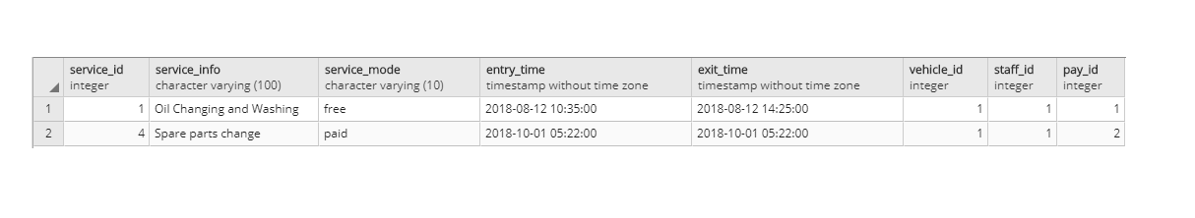

1. Service providers can view all customer records.

 SERVICE_PROVIDER.PRO_ID=2

(CUSTOMERS joinop(CUSTOMERS.CID=VEHICLES.VID) VEHICLES joinop(SERVICES.VEHICLE_ID=VEHICLES.CID) SERVICES joinop(STAFF_DETAILS.STAFF_ID=SERVICES.STAFF_ID)

STAFF_DETAILS joinop(STAFF_DETAILS.STAFF_ID=SERVICE_PROVICER.PRO_ID)

SERVICE_PROVIDERS )

select c.* from customers as c join vehicles as v on (c.cid=v.cid) join services as s on(s.vehicle_id=v.vehicle_id) join staff_details as sd on (s.staff_id=sd.staff_id) join service_providers as sp on(sd.pro_id=sp.pro_id) where sp.pro_id=2

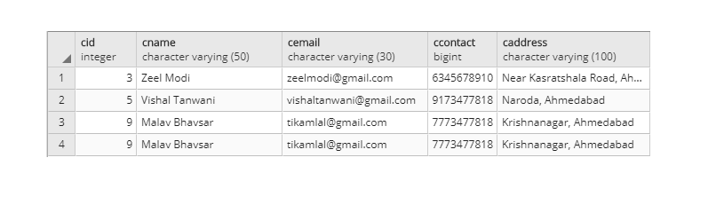

1. Service providers can view all their staff details.

        SP.PRO_ID=3(ρ(SP,SERVICE PROVIDER) joinop (SP.PRO_ID=SD.PRO_ID) ρ(SP,STAFF_DETAILS))

SELECT sd.* FROM SERVICE_PROVIDERS AS SP JOIN STAFF_DETAILS AS SD ON (SP.PRO_ID=SD.PRO_ID) where sp.pro_id=3

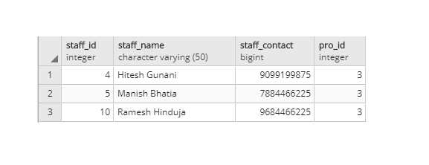

1. Service providers can search vehicle based reports.

SP.PRO_ID=2 AND VM.MODEL_ID=’i10’(

ρ(C,CUSTOMER) joinop(C.CID=V.CID) ρ(V,VEHICLES) joinop(S.VEHICLES_ID=V.VEHICLES_ID) ρ(S,SERVICES) joinop(S.STAFF_ID=SD.STAFF_ID) ρ(SD,STAFF_DETAILS) joinop(SD.PRO_ID=SP.PRO_ID) ρ(SP,SERVICE_PROVIDER)joinop(V.MODEL_ID=VM.MODEL_ID) ρ(VM,VEHICLE_MODEL))

select vm.* from customers as c join vehicles as v on (c.cid=v.cid) join services as s on(s.vehicle_id=v.vehicle_id) join staff_details as sd on (s.staff_id=sd.staff_id) join service_providers as sp on(sd.pro_id=sp.pro_id) join vehicle_models as vm on(v.model_id=vm.model_id) where sp.pro_id=2 and vm.model_name='i10’

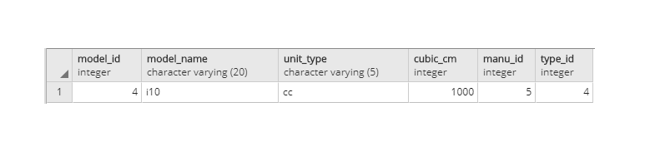

1. Retrieve customers who have vehicles such as activa etc.

ρ(C,CUSTOMERS) joinop(C.CID=V.CID) ρ(V,VEHICLES) joinop(V.MODEL_ID=VM.MODEL_ID) ρ(VM,VEHICLE_MODEL)

SELECT C.* FROM CUSTOMERS AS C join VEHICLES AS V on (C.cid=V.cid) JOIN VEHICLE_MODELS AS VM ON (V.MODEL_ID=VM.MODEL_ID) WHERE VM.MODEL_NAME='Activa'

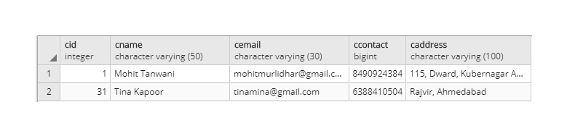

1. Retrieve customers who have two wheelers.

VT.WHEELES=2

(ρ(C,CUSTOMERS) joinop(C.CID=V.CID) ρ(V,VEHICLES)joinop(V.MODEL_ID=VM.MODEL_ID) ρ(VM,VEHICLE_MODELS)joinop(VM.TYPE_ID=VT.TYPE_ID) ρ(VT,VEHICLE_TYPES))

SELECT C.* FROM CUSTOMERS AS C join VEHICLES AS V on (C.cid=V.cid) JOIN VEHICLE_MODELS AS VM ON (V.MODEL_ID=VM.MODEL_ID) JOIN VEHICLE_TYPES AS VT ON (VM.TYPE_ID=VT.TYPE_ID) WHERE VT.wheels=2

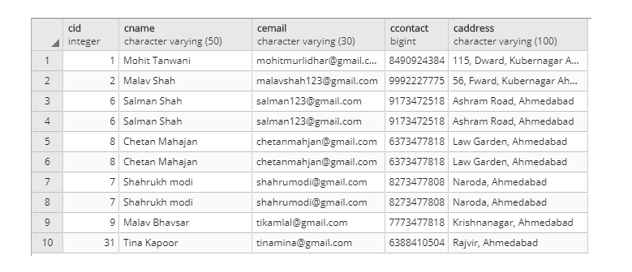

1. Retrieve the number of customers who have ‘truck’

 MODEL_NAME,COUNT(MODEL_NAME)(  VM.MODEL_NAME=”Truck” 🡪MODEL_NAME (( ρ(C,CUSTOMERS) joinop(C.CID=V.CID) ρ(V,VEHICLES)joinop(V.MODEL_ID=VM.MODEL_ID AND ) ρ(VM,VEHICLE_MODELS)))

SELECT vm.model_name,Count(vm.model_name) FROM CUSTOMERS AS C join VEHICLES AS V on (C.cid=V.cid) JOIN VEHICLE_MODELS AS VM ON (V.MODEL_ID=VM.MODEL_ID) WHERE VM.MODEL_NAME='Activa' group by vm.model_name

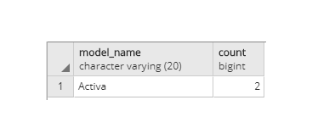

1. Retrieve number of manufacturers for particular vehicle.

 MODEL_NAME,MODEL_NAME (ρ(M,MANUFACTURES) joinop(M.MANU_ID=VM.MANU_ID) ρ(VM,VEHICLE_MODELS)

Select m.manu_name,vm.model_name from manufacturers as m join vehicle_models as vm on (m.manu_id=vm.manu_id)

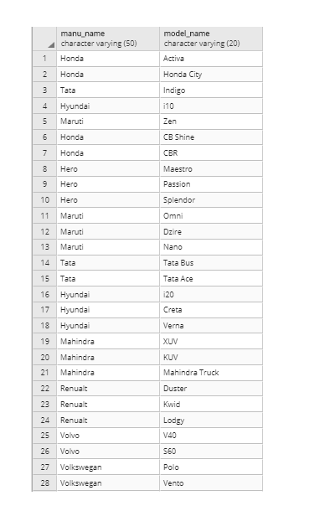

1. Retrieve number of times vehicle has come for service.

  COUNT(SERVICE_ID) ( VEHICLE_ID=1 (SERVICES))

Select count(service_id) from services where vehicle_id=1

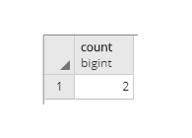

1. Retrieve staff details for service.

ρ(S,SERVICES) joinop(S.STAFF_ID=SD.STAFF_ID) ρ(SD,STAFF_DETAILS)

select s.*, sd.staff_name from services as S join staff_details as sd on(s.staff_id=sd.staff_id)

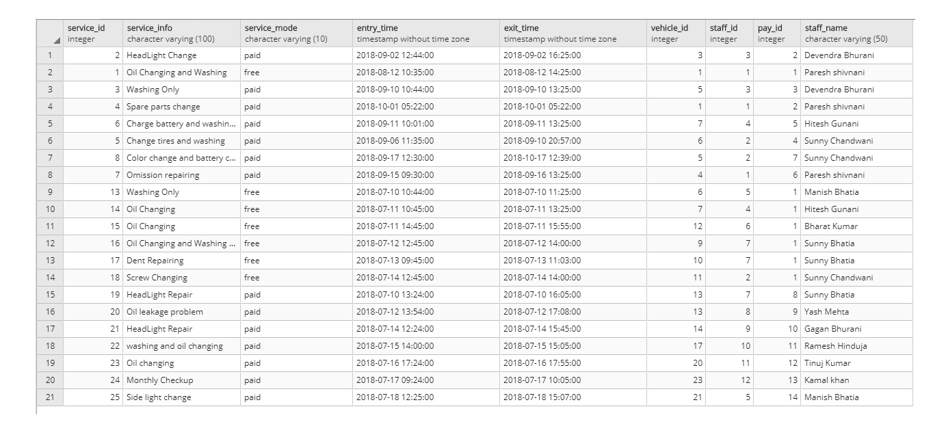

1. Retrieve the details of free services of particular vehicle.

S.SERVICE_MODE=”FREE”(ρ(S,SERVICES) joinop(S.VEHICLE_ID=V.VEHICLE_ID) ρ(V,VEHICLES))

select s.* from services as s join vehicles as V on (s.vehicle_id=v.vehicle_id) where s.service_mode='free'

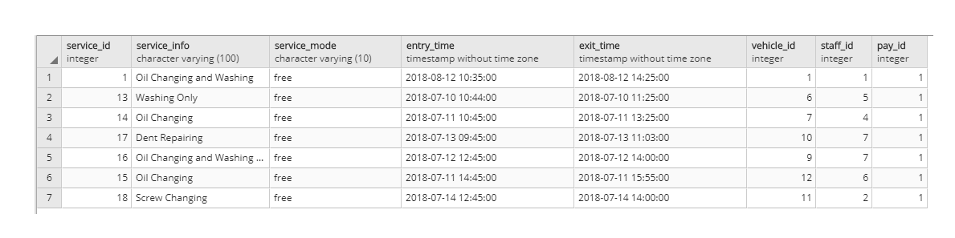

1. Retrieve service providers with maximum customer satisfaction.

 DISTINCT(PRO

VIDER_NAME) (ρ(SP,SERVICE_PROVIDER) joinop(SP.PRO_ID=SD.PRO_ID) ρ(SD,STAFF_DETAILS)joinop(SD.STAFF_ID=S.STAFF_ID) F.FEED_RATING=5(ρ(S,SERVICES)joinop(F.SERVICE_ID=S.SERVICE_ID) ρ(F,FEEDBACK))

select distinct sp.* from service_providers as sp join staff_details as sd on (sp.pro_id=sd.pro_id) join services as s on (sd.staff_id=s.staff_id) join feedbacks as f on (f.service_id=s.service_id) where f.feed_ratings=5

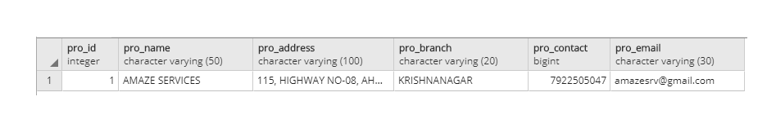

1. Vehicles of which manufacturers required more services than others.

 MANU_IDℱCOUNT(MANU_ID),MANU_NAME(ρ(S,SERVICES) joinop(S.VEHICLE_ID=V.VEHICLE_ID) ρ(V,VEHICLES) joinop(V.MODEL_ID=VM.MODEL_ID) ρ(VM,VEHICLE_MODELS)joinop(VM.MANU_ID=M.MANU_ID) ρ(M,MANUFACTURES)

select count(m.manu_id),m.manu_name from services as s join vehicles as v on (s.vehicle_id=v.vehicle_id) join vehicle_models as vm on (v.model_id=vm.model_id) join manufacturers as m on (vm.manu_id=m.manu_id) group by m.manu_id order by count(m.manu_id) desc limit 1

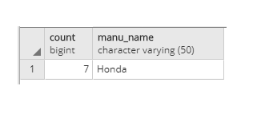

1. Retrieve manufacturers who has sold maximum vehicles.

 MANU_IDℱCOUNT(MANU_ID),MANU_NAME(ρ(V,VEHICLES) joinop(V.MODEL_ID=VM.MODEL_ID) ρ(VM,VEHICLE_MODELS) joinop(VM.MANU_ID=M.MANU_ID) ρ(M,MANUFACTURES)

select count(m.manu_id),m.manu_name from vehicles as v join vehicle_models as vm on (v.model_id=vm.model_id) join manufacturers as m on (vm.manu_id=m.manu_id) group by m.manu_id order by count(m.manu_id) desc limit 1

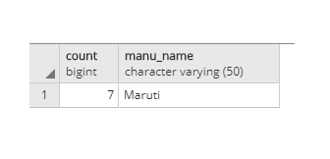

1. Retrieve service providers who had done maximum service for particular vehicle.

ρ(SP,SERVICE_PROVIDER) joinop(SP.SERVICE_PRO_ID=S.SERVICE_PRO_ID) ρ(S,SERVICES)joinop(V.MODEL_ID=VM.MODEL_ID) VM.MODEL_NAME=”Activa”(ρ(V,VEHICLES)joinop(VM.MODEL_ID=VM.MANU_ID) ρ(VM,VEHICLE_MODELS))

select sd.* from staff_details as sd join services as ss on(sd.staff_id=ss.staff_id) join vehicles as vc on(ss.vehicle_id=vc.vehicle_id) join vehicle_models as vv on(vc.model_id=vv.model_id) where vv.model_name='i10';

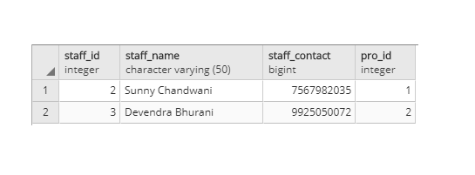

1. Retrieve staff names who had done service till now for particular vehicle.

M <-  model_id ( model_name=’i10’ (VEHICLE_MODELS))

V <-  vehicle_id (VEHICLES)

VM <- M joinop V (m.model_id=vm.model_id)

Result <-  staff_name   vehicle_id=vm.vehicle_id (STAFF_DETAILS joinop (staff_details.staff_id=services.staff_id) SERVICES)

SELECT S.STAFF_NAME FROM vehicle_mgmt.STAFF_DETAILS AS S JOIN vehicle_mgmt.SERVICES AS SS ON SS.STAFF_ID=S.STAFF_ID WHERE SS.VEHICLE_ID IN (SELECT V.VEHICLE_ID FROM vehicle_mgmt.VEHICLES AS V JOIN (SELECT M.MODEL_ID FROM vehicle_mgmt.VEHICLE_MODELS AS M WHERE M.model_name like 'i10') AS VM ON V.MODEL_ID=VM.MODEL_ID)

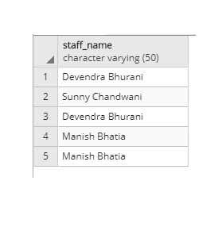

1. Retrieve number of staffs according to service providers.

  PRO_IDℱPRO_NAME,ℱCOUNT(STAFF_ID)( ρ(SD,STAFF_DETAILS) joinop(SD.PRO_ID=SP.PRO_ID) ρ(SP,SERVICE_PROVIDER))

Select sp.pro_name,count(sd.staff_id) from staff_details as sd join service_providers as sp on (sd.pro_id=sp.pro_id) group by sp.pro_id

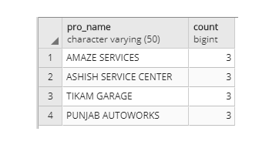

1. Retrieve customer detail who have purchased vehicles after particular years.

V.YEAR_PURCH>=2015(ρ(C,CUSTOMERS) joinop(C.CID=V.CID) ρ(V,VEHICLES))

Select c.* from customers as c join vehicles as v on (c.cid=v.cid) where v.year_purch>=2015

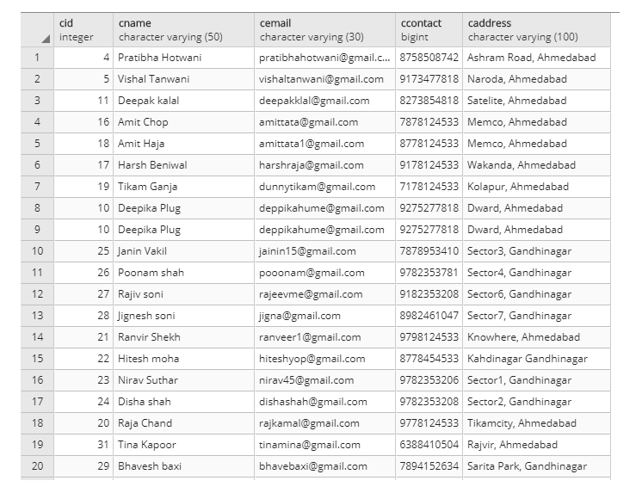

1. Select list of customers who have not serviced their vehicles yet.

(ρ(C,CUSTOMERS) joinop(C.CID=V.CID) ρ(V,VEHICLES))-( ρ(C,CUSTOMERS)joinop(C.CID=V.CID) ρ(V,VEHICLES)joinop(V.VEHICLE_ID=S.VEHICLE_ID) ρ(S,SERVICES))

Select c.* from customers as c join vehicles as v on(c.cid=v.cid) except

Select c.* from customers as c join vehicles as v on(c.cid=v.cid) join services as s on (v.vehicle_id=s.vehicle_id)

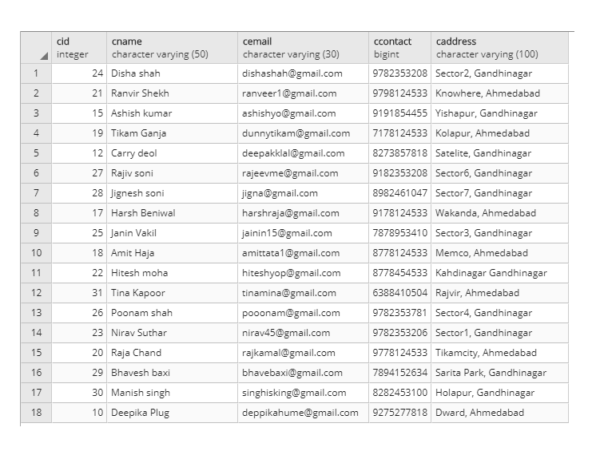

1. Retrieve vehicle types who requires maximum services.

CG <- ((type_id)ℱ(type_id) VEHICLE_TYPESjoinop (vehicle_types.type_id=vehicle_models.type_id) VEHICLE_MODEL joinop (vehicle_models.model_id=vehicles.model_id) VEHICLES joinop (vehicles.vehicle_id=services.vehicle_id) SERVICES )

CGG <-   cg.type_id (CG)

Result<-  type_name (VEHICLE_TYPESjoinop (vehicle_types.type_id=cgg.type_id) CGG)

select vtt.type_name from vehicle_mgmt.vehicle_types as vtt where vtt.type_id IN

(select cg.typess as sty from

(select count(vt.type_id) as vhcl_t,vt.type_id as typess from

vehicle_mgmt.vehicle_types as vt join

vehicle_mgmt.vehicle_models as vm on vm.type_id=vt.type_id

join vehicle_mgmt.vehicles as v on vm.model_id=v.model_id

join vehicle_mgmt.services as s on v.vehicle_id=s.vehicle_id group by vt.type_id order by vhcl_t desc limit 1) as cg);

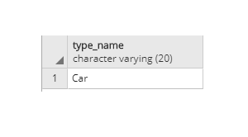

1. Which customer have paid maximum amount of payment.

(ρ(P,PAYMENTS) joinop(P.PAY_ID=S.PAY_ID) ρ(S,SERVICES)joinop(S.VEHICLE_ID=V.VEHICLE_ID) ρ(V,VEHICLES)joinop(C.CID=V.CID) ρ(C,CUSTOMERS)

select c.* from payments as p join services as s on (p.pay_id=s.pay_id) join vehicles as v on (s.vehicle_id=v.vehicle_id) join customers as c on (c.cid=v.cid) order by p.amount desc limit 1

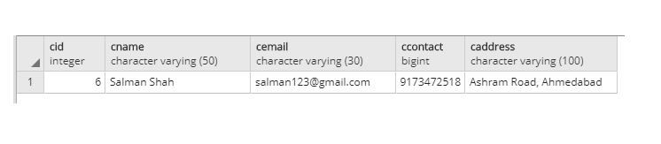

1. Which service provider had received maximum amount for servicing particular vehicle.

(ρ(P,PAYMENTS) joinop(P.PAY_ID=S.PAY_ID) ρ(S,SERVICES)joinop(S.STAFF_ID=SD.STAFF_ID) ρ(SD,STAFF_DETAILS)joinop(S.STAFF_ID=SD.STAFF_ID) ρ(SP,SERVICE_PROVIDERS)

select sp.* from payments as p join services as s on (p.pay_id=s.pay_id) join staff_details as sd on (s.staff_id=sd.staff_id) join service_providers as sp on (sd.pro_id=sp.pro_id) order by p.amount desc limit 1

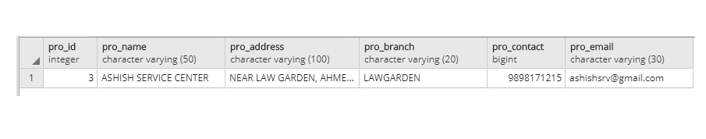

1. Which vehicle had required maximum time to service.

  VEHICLE_ID, (EXIT_TIME-ENTRY_TIME)( ρ(V,VEHICLES)joinop(S.VEHICLE_ID=V.VEHICLE_ID) ρ(S,SERVICES))

Select v.vehicle_id,s.exit_time-s.entry_time FROM vehicles as v JOIN services as s on (s.vehicle_id=v.vehicle_id) order by s.exit_time-s.entry_time desc

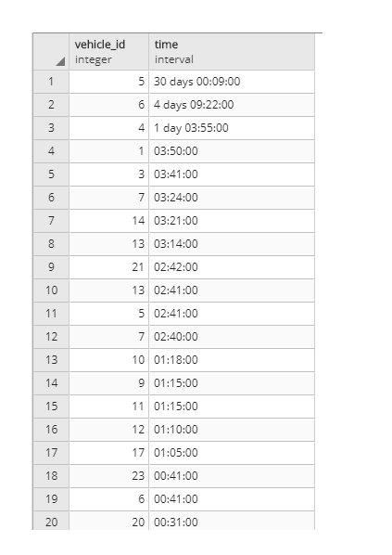

1. Which payment method customers are most likely to use.

  ℱCOUNT(*)PAY_MODE(PAYMENTS)

Select pay_mode from payments group by pay_mode order by count(*)desc limit 1

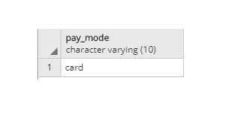

1. Which service time customer prefers most?

QQ <- month ℱ (count(month)) SERVICES

Result <-  QQ.months (QQ)

select qq.months from (select count(extract(month from s.entry_time)) as sg,extract(month from s.entry_time) as months from vehicle_mgmt.services as s group by extract(month from s.entry_time) order by sg desc limit 1) as qq;

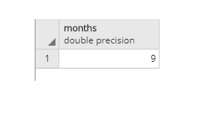

1. Retrieve top 5 staff details who had maximum ratings in their service feedback for particular vehicle type.

HG <-  model_id ( type_name=’Car’ VEHICLE_MODELS joinop (vehicle_models.model_id=vehicle_types.model_id) VEHICLE_TYPES)

R1 <-  vehicle_id (VEHICLES joinop (vehicles.model_id=HG.model_id) HG)

R2 <-  staff_id,feed_ratings (SERVICES joinop (services.service_id=feedbacks.service_id) FEEDBACKS joinop (feedbacks.vehicle_id=R1.vehicle_id) R1)

R3 <-  staff_id (R2)

Result <-  staff_name (STAFF_DETAILS joinop (staff_details.staff_id=R3.staff_id) R3)

select sd.staff_name from vehicle_mgmt.staff_details as sd where sd.staff_id in (select distinct(hj.gh) as sids from (select ss.staff_id as gh,ff.feed_ratings from vehicle_mgmt.services as ss join vehicle_mgmt.feedbacks as ff on ss.service_id=ff.service_id where ss.vehicle_id IN (select vv.vehicle_id from vehicle_mgmt.vehicles as vv where vv.model_id IN (select vm.model_id from vehicle_mgmt.vehicle_models as vm join vehicle_mgmt.vehicle_types as vt on vm.type_id=vt.type_id where vt.type_name='Car')) order by ff.feed_ratings desc LIMIT 5) as hj);

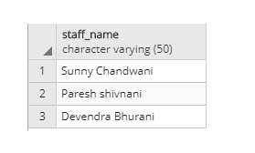

1. List all the customers who had given feedback for all services.

select v1.cid,v3.cname from vehicle_mgmt.vehicles as v1 join

(select t1.vid as vehcle_id from (select count(j2.feed_id) as cnt1,j1.vehicle_id as vid from vehicle_mgmt.services as j1 join vehicle_mgmt.feedbacks as j2 on j2.service_id=j1.service_id group by j1.vehicle_id) as t1 join (select count(cnt2.service_id) as cnt2,cnt2.vehicle_id as vid from vehicle_mgmt.services as cnt2 group by cnt2.vehicle_id) as t2 on t1.vid=t2.vid where t1.cnt1=t2.cnt2) as v2 on v1.vehicle_id=v2.vehcle_id join vehicle_mgmt.customers as v3 on v1.cid=v3.cid;

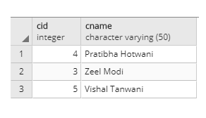

1. Retrieve which vehicle model requires least maintainance than other vehicle models for particular vehicle type.

select vm.model_name,t2.average_cost as maintance_cost from vehicle_mgmt.vehicle_models as vm join (select (t1.smc/t1.nvr)::integer as average_cost,t1.mid as model_id,t1.nvr as no_of_v from (select sum(eg.no_of_vehicles_registered) as nvr,sum(eg.no_of_time_it_requires_service) as nrs ,sum(eg.sum_of_maintance_cost) as smc,eg.model_id as mid from (select count(df.vid) as no_of_vehicles_registered,df.c2 as no_of_time_it_requires_service,df.c3 as sum_of_maintance_cost,df.mid as model_id from (select vv.vehicle_id as vid,(select count(*) from vehicle_mgmt.services as ss where ss.vehicle_id=vv.vehicle_id)as c2, (select sum(pp.amount) from vehicle_mgmt.payments as pp join vehicle_mgmt.services as ss on ss.pay_id=pp.pay_id where ss.vehicle_id=vv.vehicle_id) as c3, vm.model_id as mid from vehicle_mgmt.vehicles as vv join vehicle_mgmt.vehicle_models as vm on vv.model_id=vm.model_id join vehicle_mgmt.vehicle_types as vt on vm.type_id=vt.type_id where vt.type_name=?) as df group by mid,df.c2,df.c3) as eg group by eg.model_id) as t1)as t2 on t2.model_id=vm.model_id order by case when t2.average_cost is null then 0 else 0 end,maintance_cost desc nulls first LIMIT 5

